The bestselling and award-winning author of The Amen Sisters
confronts temptation and redemption in a powerful new story

UP POPS THE DEVIL

By Angela Benson

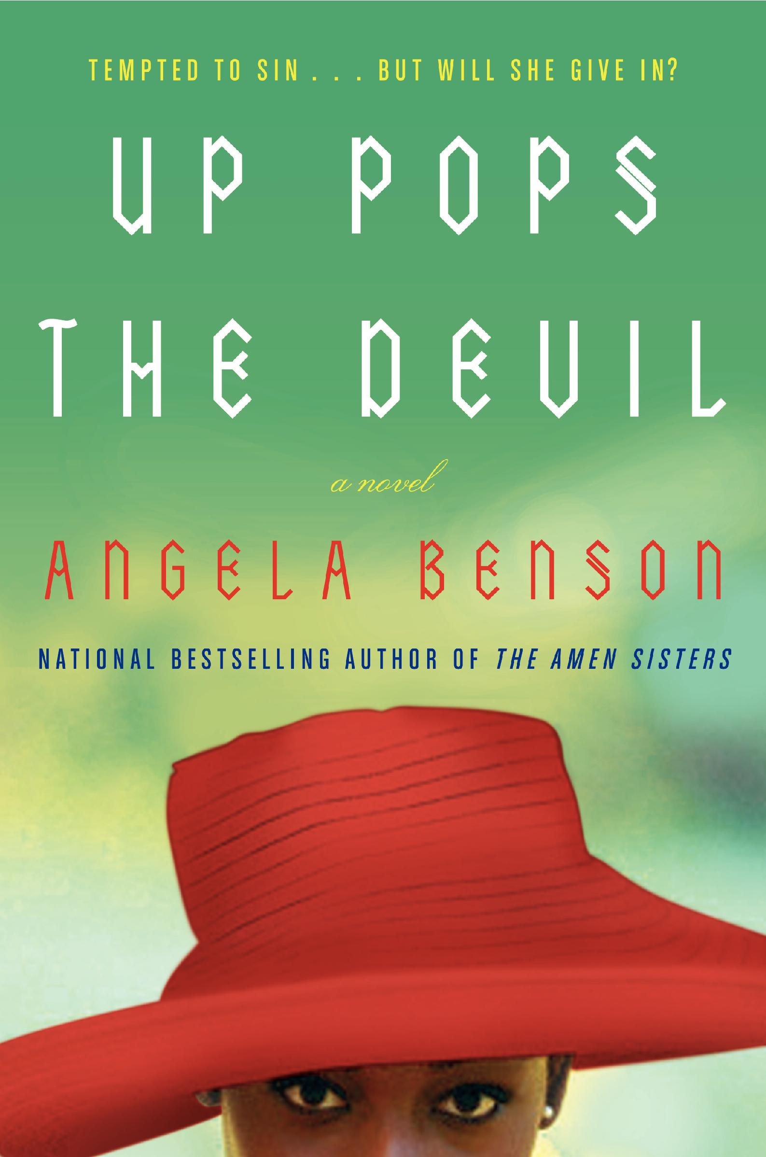
Essence bestseller Angela Benson returns with UP POPS THE DEVIL (Avon A; Pub Date August 1, 2008; $13.95), a rich and emotional story of love, betrayal, and the rocky path to redemption. “Preacher” Winters has completed a two-year stint in prison equipped with a determination to live his life honorably—but first he has to face the women who are waiting for him on the outside. There’s his sister and business partner Loretta, who has kept their drug business thriving under the assumption that he’ll rejoin her upon his return, and his girlfriend Tanya, mother to his two young sons and a woman who expects to maintain the luxurious lifestyle he was able to provide in the old days.

While Preacher struggles to resist the temptations of his former life, he also tries to live up to the belief instilled in him by his mentor and probation sponsor Barnard Jenkins. Things seem to be going well when Preacher is given an opportunity to take over a business through the prison outreach program that Barnard runs, but he soon learns that his path is not as smooth as he may have thought. Complications ensue when Preacher encounters Serena, an ex-girlfriend with whom he shares a dark secret…and who is now married to Barnard. Then, yet another woman pops up in his life: Natalie, Barnard’s sister with whom Preacher immediately feels a connection. Preacher’s still set on making things work with Tanya, though, and building the family life that his two beloved sons deserve. But in the end, he’ll have to learn that sometimes you have to give up what you want in order to move forward.

Discover the obstacles and surprises that life has to offer in UP POPS THE DEVIL, a powerful, moving, and juicy story as only Angela Benson can tell it.

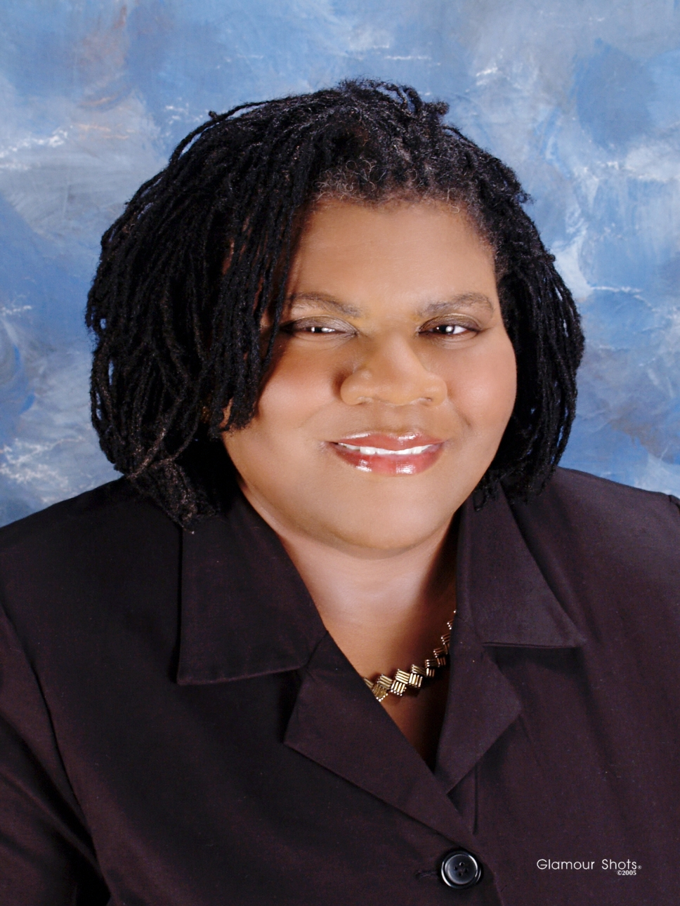
ABOUT THE AUTHOR

Angela Benson is a graduate of Spelman College and the author of numerous novels, including the Christy Award-nominated Awakening Mercy and the Essence bestseller The Amen Sisters. She is currently an associate professor at the University of Alabama and lives in Tuscaloosa.

